Understanding Abstracts for Statements of Claim in Montana
The Montana Claims Examination Manual, Rule 2(a), defines an abstract as “the computer printout of each claim of an existing water right showing the information submitted on the original or amended statement of claim, any changes authorized by these rules or by the water court, remarks noting any obvious factual or legal issues presented by the claim, and other remarks explaining the nature and extent of the claimed water right.”
An abstract will typically contain the following elements of a water right:
1. Owner and address
2. Purpose
3. Source
4. Type of irrigation system (for irrigation claims)
5. Priority date
6. Type of historical right
7. Flow rate
8. Volume
9. Maximum acres
10. Period of use
11. Point of diversion
12. Means of diversion
13. Reservoir (if applicable)
14. Place of use.
An abstract also includes the basin code, water right identification number, surface water or groundwater designation, climatic area for irrigation, and period of diversion. This article describes these elements as they are reflected on an abstract for a statement of claim. All definitions of water right elements described in this article are generally drawn from Rule 2 of the Montana Claims Examination Manual, and portions of several different abstracts are used as examples below.
Over 200,000 water right claims have been filed in Montana’s general stream adjudication, and their abstracts reflect their status as statements of claim. Abstracts are also generated for water right permits, certificates, and reservations. This is designated on an abstract after the basin code and water right identification number:
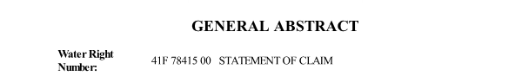

The version type indicates whether the abstract is showing the original right, post-decree modifications from the Montana Water Court, or a change authorization. Version status indicates whether an abstract is active, or a different status such as dismissed or withdrawn.
"Owner" means any person, according to Section 85-2-102, MCA, who has title or interest in water rights or properties. The claim owner is reflected with a mailing address:
"Priority Date" means the allocation date, or date of first use associated with a beneficial use of water which determines ranking among water rights, usually expressed by day, month, and year. The priority date is shown with its enforceable priority date, and the type of historical right will indicate whether the claim’s historical basis was a filed right, use right, or based upon a pre-1973 District Court decree. Most claims will show the priority date and enforceable priority date as the same: 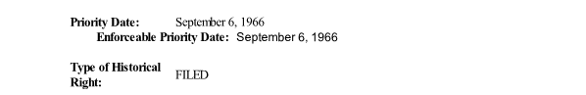
Late claims (those filed pursuant to Section 85-2-221, MCA) will show an enforceable priority date of June 30, 1973:
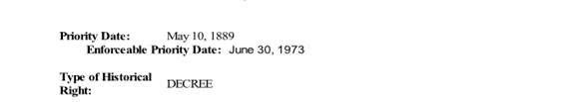
The purpose of a right will indicate whether its use includes irrigation, stock, domestic, municipal, industrial, or another purpose such as fishery or fish and wildlife.
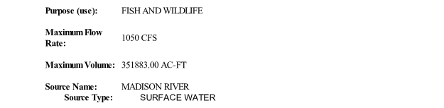

"Flow Rate" means the rate at which water has been diverted, impounded, or withdrawn from the source for beneficial use. Historically, flow rate was measured in miner's inches. The official unit of measurement for water in Montana is cubic feet per second, or CFS. Section 85-2-103, MCA. 40 miner's inches equals one CFS, or 448.83 gallons per minute. Small flows are measured in gallons per minute and larger flows are measured in cubic feet per second.
Volumes are quantified in acre-feet per year. An acre-foot is the amount of water necessary to cover one acre with one foot of water. One acre-foot is about 325,000 gallons. Not all claims are decreed a quantified volume, such as direct flow irrigation claims, and many stock claims.
The source name is the natural source from which water is diverted or otherwise taken for a beneficial use, and the source type reflects whether the right is for surface or ground water.
"Point of Diversion" (POD) means the location or locations where water is diverted from the source.
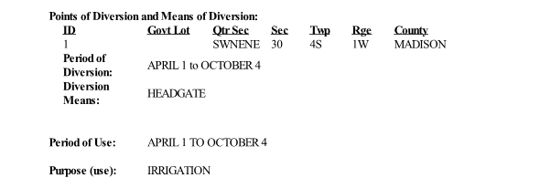
For instream or inlake appropriations, the point of diversion is the portion of the source in which the instream or inlake use occurs. Period of use is generally defined as the time from the first use of the year through the last use of the year, and period of diversion indicates the time that water is diverted for beneficial use. For many rights that do not involve storage, period of use and period of diversion may be the same.
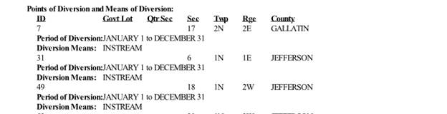

"Place of Use" (POU) means the lands, facilities, or sites where water is beneficially used. For irrigation, the place of use will be shown with the maximum irrigated acres.
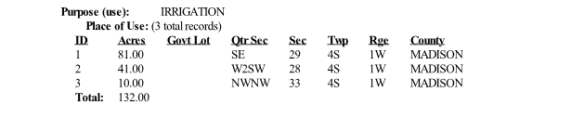
For a municipal well, the place of use may be depicted as follows:
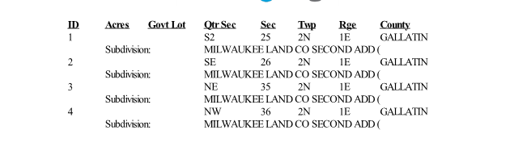
An instream stock right will be depicted this way if the stock use extends along a stretch of a stream or river that encompasses multiple quarters or sections in a legal description:
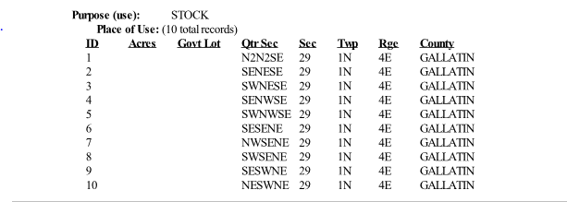
An instream flow right for fisheries will have a place of use that details the different reaches on which the flow rate is claimed, similar to the description for the instream stock right. The place of use parcels listed should not be used to add up the flow rate. The flow rate for the claim is designated under the maximum flow rate and maximum volume fields of the abstract. The place of use should be used to interpret the specific stream reaches where the instream flow would be protected for that particular claim. The place of use for an instream flow right for fisheries is reflected this way:
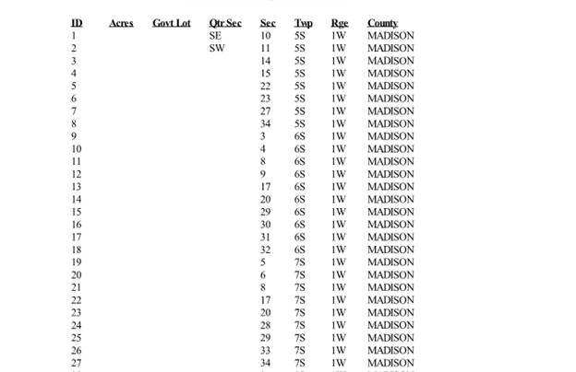
The point of diversion and place of use for instream and inlake claims are clarified during examination:
RULE 31. POINT OF DIVERSION (POD) AND MEANS OF DIVERSION FOR INSTREAM OR INLAKE APPROPRIATIONS. The department’s examination of the claimed POD for instream or inlake other uses claims shall follow the procedures described in Rule 8, W.R.C.E.R. In addition, the following procedures will apply to the examination of the POD for such claims. (a) For instream water use, the legal land description of the POD will be the same as the legal land description of the POU. (b) The claimed POD may be revised by the department so that the POD and POU legal land descriptions for instream water use will be the same. (c) A clarifying remark should be added to the point of diversion to provide a general geographic description of the instream reach claimed and to promote the public’s ability to understand the extent of the claim. Example: THIS RIGHT FOR INSTREAM USE APPLIES FROM SMITH DAM IN JONES COUNTY DOWNSTREAM TO THE CONFLUENCE OF THE NORTH FORK OF ROCK CREEK WITH THE GREEN RIVER IN MACON COUNTY. (d) For all instream or inlake surface appropriations, the claimed means of diversion will be changed during the department’s examination to “INSTREAM” or “INLAKE.”

Abstracts reflect a geocode, which assists the Montana Department of Natural Resources and the Montana Department of Revenue in updating ownership for water rights transfers.
The last field in an abstract may contain remarks, including informational remarks and issue remarks.
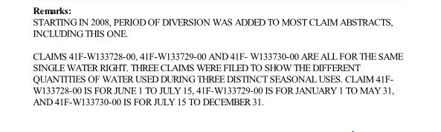
Remarks are added by the department or the Water Court to limit or define a water right, to explain unique aspects of a water right, and to identify potential factual and legal issues. Remarks that limit, define, or explain unique aspects of a claim are “clarifying” or informational remarks and appear on the abstract under the element they clarify or at the end of the abstract if they contain general information. Remarks that identify potential factual or legal issues are “issue” remarks and appear in the issue remark box at the end of the abstract. Because issue remarks must be resolved by the Montana Water Court pursuant to Section 85-2-248, MCA, and also because objectors often use issue remarks to decide whether to object to a claim, these remarks are some of the most important aspects of an abstract.

